 | Stage 3 Physics  2016
  Circular Motion Practical (5%)

Student name:

This diagram refers to a stage 3 investigation where students analysed the circular motion of a rubber stopper.  The students were required to investigate the relationship that exists between various variables and the force required to maintain uniform circular motion. | 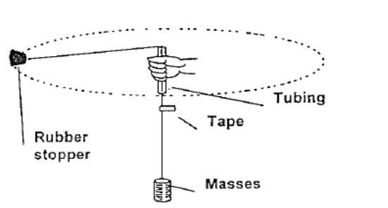

Note: The rubber stopper can have varying speed at any radius due to the fact that the person swinging the stopper around had control over how hard the string pulled in on the stopper. The masses hung from the string provided the pull on the string.

1. A stage 3 Physics student chose to keep the force on the string the constant and calculate the speed of the stopper for different radii. Below is a list of events performed by students in the lab. Place the steps in the correct order (A - E) in the space provided below. (2 marks)

- Timed the stopper for 20 swings. The period is 1/20 of this time.
- Repeated for at least 5 radii with the same mass on the string.
- Put say 100 g on the string and swung the stopper in a circle. The speed was adjusted to match the radius by lining up the tape mark.
- The weight (tension T), radius r, period T and speed v were all tabulated.
- Placing a marker on the string just below the glass tube set the radius. (At about 50 cm when the stopper was swung).

The student struggled to keep the marker in the same spot and estimated her uncertainties in the readings as indicated in the results table below:

The following results were obtained:

Mass of stopper used = 47.5 grams
Mass of slotted weights used = 100 grams

Radius r(m) | Time for 20 swings (s) |  | Average period T  ( ) | V =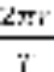  (m.s⁻¹) | V² ( )
Radius r(m) | Trial 1 | Trial 2 | Average period T  ( ) |  | V² ( )
0.30±0.02 | 15.15±2 | 15.20±2 | 0.76±0.10
0.40±0.03 | 16.94±2 | 17.00±2 | 0.85±0.10
0.50±0.04 | 18.55±2 | 18.90±2 | 0.94±0.10
0.60±0.05 | 21.42±1 | 21.22±1 | 1.07±0.05
0.70±0.06 | 22.95±1 | 22.85±1 | 1.15±0.05

PROCESSING OF RESULTS:

2. Consider the measurement radius (r) = 0.30 ±0.02. Calculate the % error in the measurement and therefore the absolute error in the measurement for the V column. (Do Not fill this answer in on the above table). (3 marks)

3. Using the graph paper provided plot a graph of T (y-axis) against r (x-axis), including the error bars, and draw the curve of best fit through the points. (4 marks)

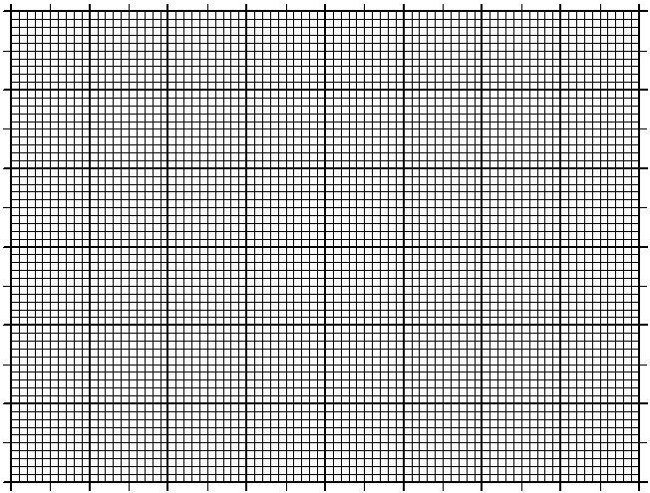

4. What can you conclude from the graph about the relationship between r and T?
(1 mark)

NOTE: Ignore error calculations unless told otherwise.

5. Complete the table on page 2, remember to complete any unfinished units that should appear in the column headers. (5 marks)

6. Graph the speed (v) versus the radius (r) in the space below. (4 marks)

Note: Plot v on the y-axis and r on the x-axis.

7. Draw a graph of the speed squared (v²) versus the radius (r) on the graph paper provided below. (4 marks)

Note: Plot v² on the y-axis and radius, r on the x-axis.

8. What can be determined between the graphical relationships seen here? (2 marks)

r & v
r & v²

9. Using the equations of circular motion, calculate the gradient of the graph in Q7 above. Be sure to indicate on the graph which points were used. (3 marks)

10. What does this slope represent? Compare it to the value obtained using the mass of the stopper and the centripetal force and comment on the validity of the experiment.
(6 marks)

11. What is the equation for the straight line obtained in Q7? (2 marks)

12. Describe three errors affecting the results of the experiment above. (3 marks)

First
Second
Third

13. Use a line of data eg 0.6 m and the corresponding v², together with the mass of the stopper and calculate F_{c} = mv²/r. (2 marks)

14. Calculate the F_{c} by using the data for the slotted masses. (1 mark)

15. Calculate the % difference between your different F_{c} values. (2 marks)

16. Give three reasons why the calculate F_{c} values differ. (3 marks)

First
Second
Third

17. Give three reasons why it is desirable to use 20 swings to calculate a value for the period (T), consider aspects of error and measuring difficulties. (3 marks)

First
Second
Third

